[Date]

[Name]  
[Address]

[Other]

|  |  |  |  |
| --- | --- | --- | --- |
| Payment Escrow | Payment Type Payment Method | | Payment Date |
| Medstartr.com | Tax Deductible Donation | Credit Card | [Date] |

|  |  |  |  |  |  |
| --- | --- | --- | --- | --- | --- |
| Invoice | Quantity | Organization | 503(c)(3) EIN |  | Line Total |
| 015 | 001 | Floridata Foundation | N14000004497 | | $50.00 |
|  |  |  |  | |  |
|  |  |  |  | |  |
|  |  |  |  | Subtotal | $50.00 |
|  |  |  |  | Sales Tax | $0.00 |
|  |  |  |  | Total | $50.00 |

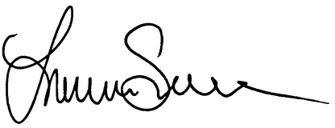

Received By: Lauren Still, Founder, Floridata Foundation

June 11, 2014

Thank you for your donation!

Floridata Foundation | 2220 W CR 201, STE 108-322, St Johns, FL 32259 | 571-480-6367  
Hello@Floridata.co